Patch manager configuration

Navigate to SSM console and select the Patch Manager

Click on Create Patch Policy

Give name for the patch policy and select scan or scan install based on the requirement:

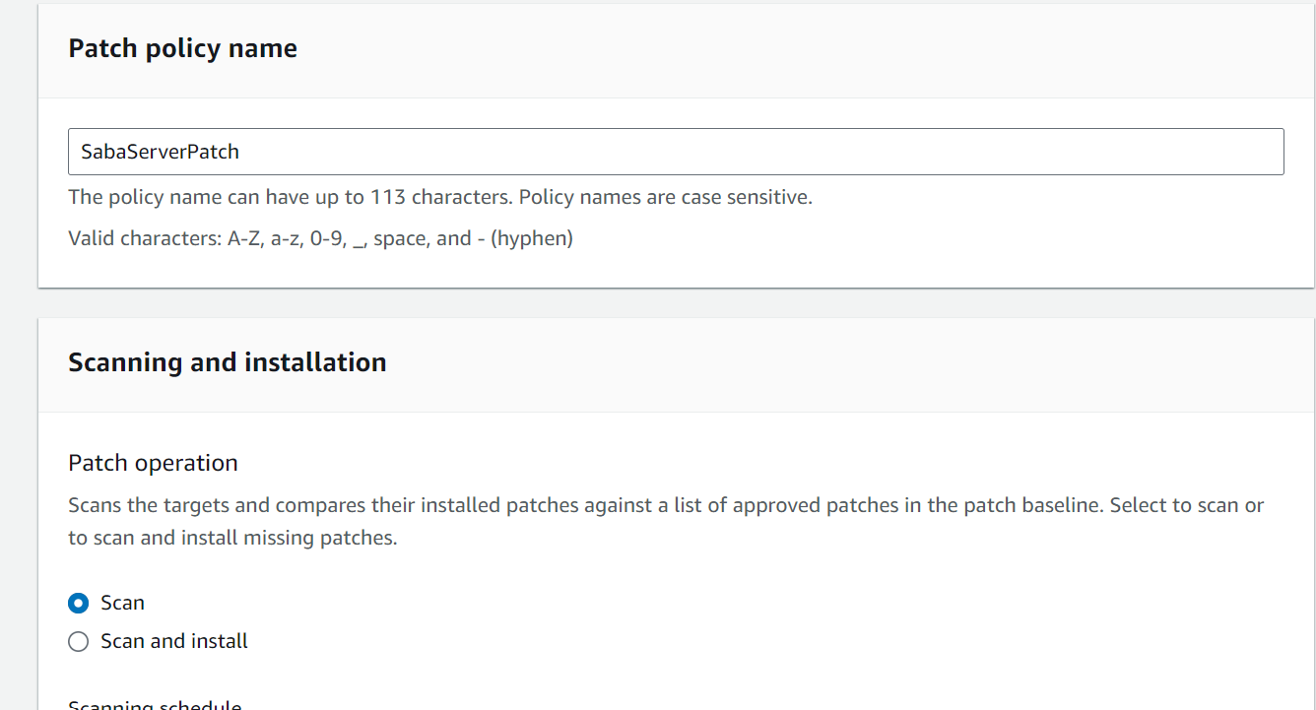

Here we are selecting on scan so it just scan all the patches available.

Next select the time on which to scan for the patches

Select the patch baseline

Here we have selected the default patch baseline

Select the target nodes , use the manual option to select the instance for scanning.

Give permission to create required instance profile and permissions for scanning.

After that click on create patch

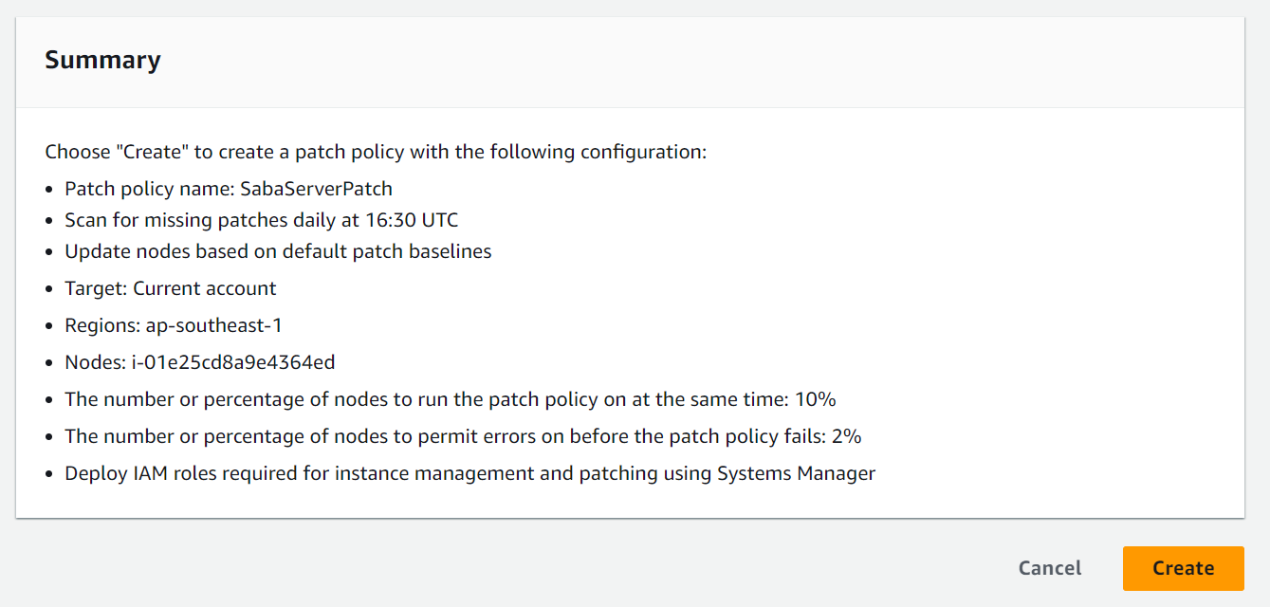

Once the patch policy is created click on the quick setup on the AWS system manager console to see the patch policy created.

For editing the patch policy click on Actions and edit .

In patch manager click on Compliance report to see the scanning result.

